# [Site name] Site Plan

## [Bree Jacob]

## WDD 420

## Overview

### Purpose

[To make a website that teaches people how to do various math tasks]

### Audience

[ n e r d s ]

## Branding

### Website Logo



## Style Guide

### Color Palette

|  |  |  |  |
| --- | --- | --- | --- |
| **Primary** | **Secondary** | **Accent 1** | **Accent 2** |
| #1f00ff | #8979ff | #ff6f00 | #ff5a00 |

### Typography

#### Heading Font: Trebuchet MS (sans-serif)

#### Paragraph Font: Courier New (monospace)

### Navigation

Home Page2 Page3

**Content**

**home page**

logo and nav, with big bold words that say “**the world of math at your fingertips”** with a call to action button that says “run while you still can” that links to the website “cool math games” the background of this section is math.png

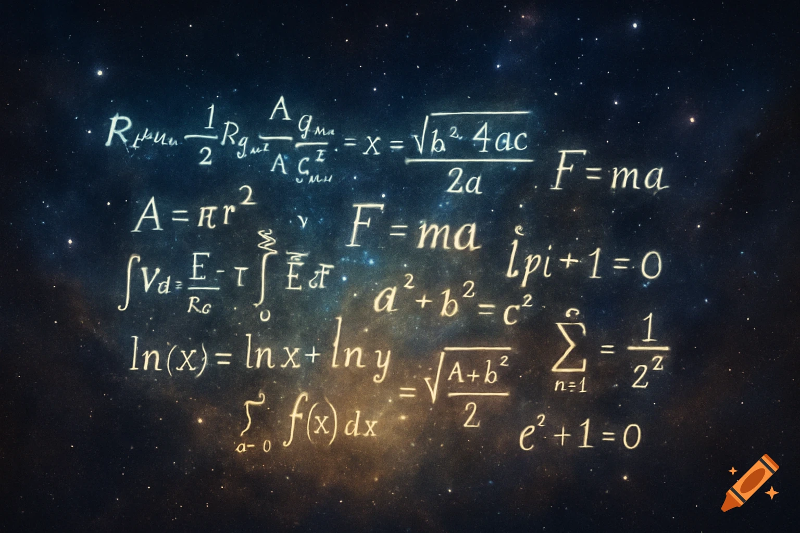

(put this under the our mission part of the page) \/ \/ \/

Unlock the power of higher mathematics with FormulaSphere—a dynamic, intuitive website that brings college‑level math formulas to life. Whether you’re tackling calculus, linear algebra, differential equations, or beyond, FormulaSphere provides clear derivations, interactive visualizations, and real‑world examples to deepen your understanding. No more flipping through dense textbooks or struggling to connect theory with application—our user‑friendly platform tailors each formula to your learning style, offers step‑by‑step walkthroughs, and equips you with downloadable cheat‑sheets for on‑the‑go reference. Perfect for students, educators, and professionals alike, FormulaSphere transforms abstract concepts into practical tools. Master complex math effortlessly—dive in and revolutionize the way you learn formulas today!

**Page 2: Complicated Math**

Quadratic Equation – ax^2 + bx + c:

To find the roots of a quadratic equation without factoring, use the quadratic formula:

x = ((-b) +- sqrt((b^2) – 4(a)(c))) / 2(a)

This works for any equation in the form ax2+bx+c=0. Plug in the values of a, b, and c from your equation. The part under the square root, b2−4ac, is called the discriminant. It tells you how many real roots the equation has: two if it's positive, one if it's zero, and none (just complex roots) if it's negative.

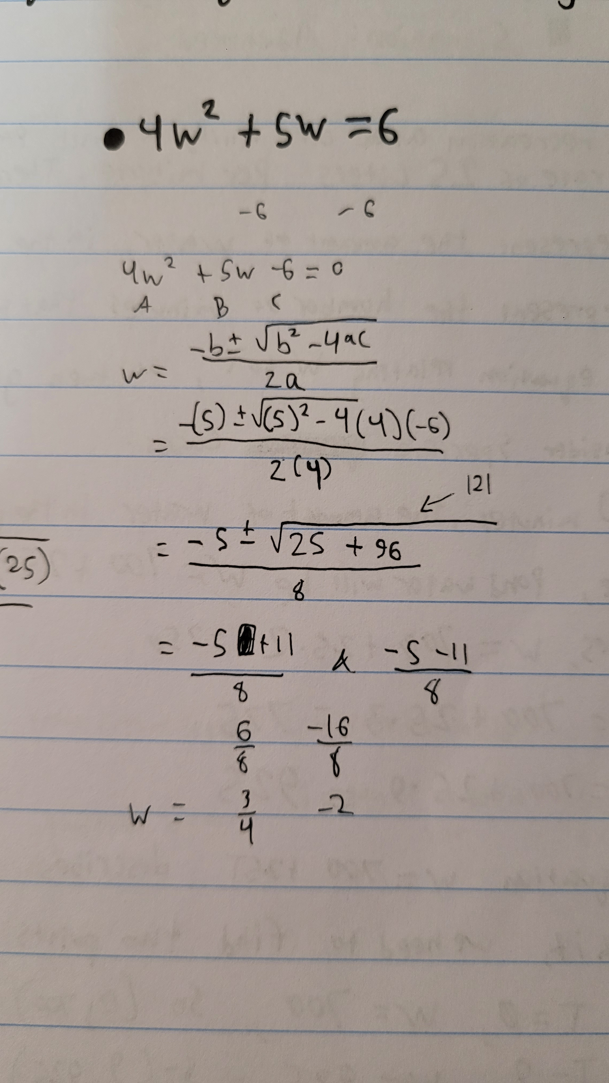

Vertex of a parabola → y = a(x – h)^2 + k → vertex = (h, k)

To find the vertex of a parabola using the equation y=a(x−h)2+k, simply identify the values of h and k. The vertex is the point (h,k). This form of the equation is called vertex form because it directly shows the vertex — just remember that the sign of h is reversed (if the equation is (x−3), then h=3).

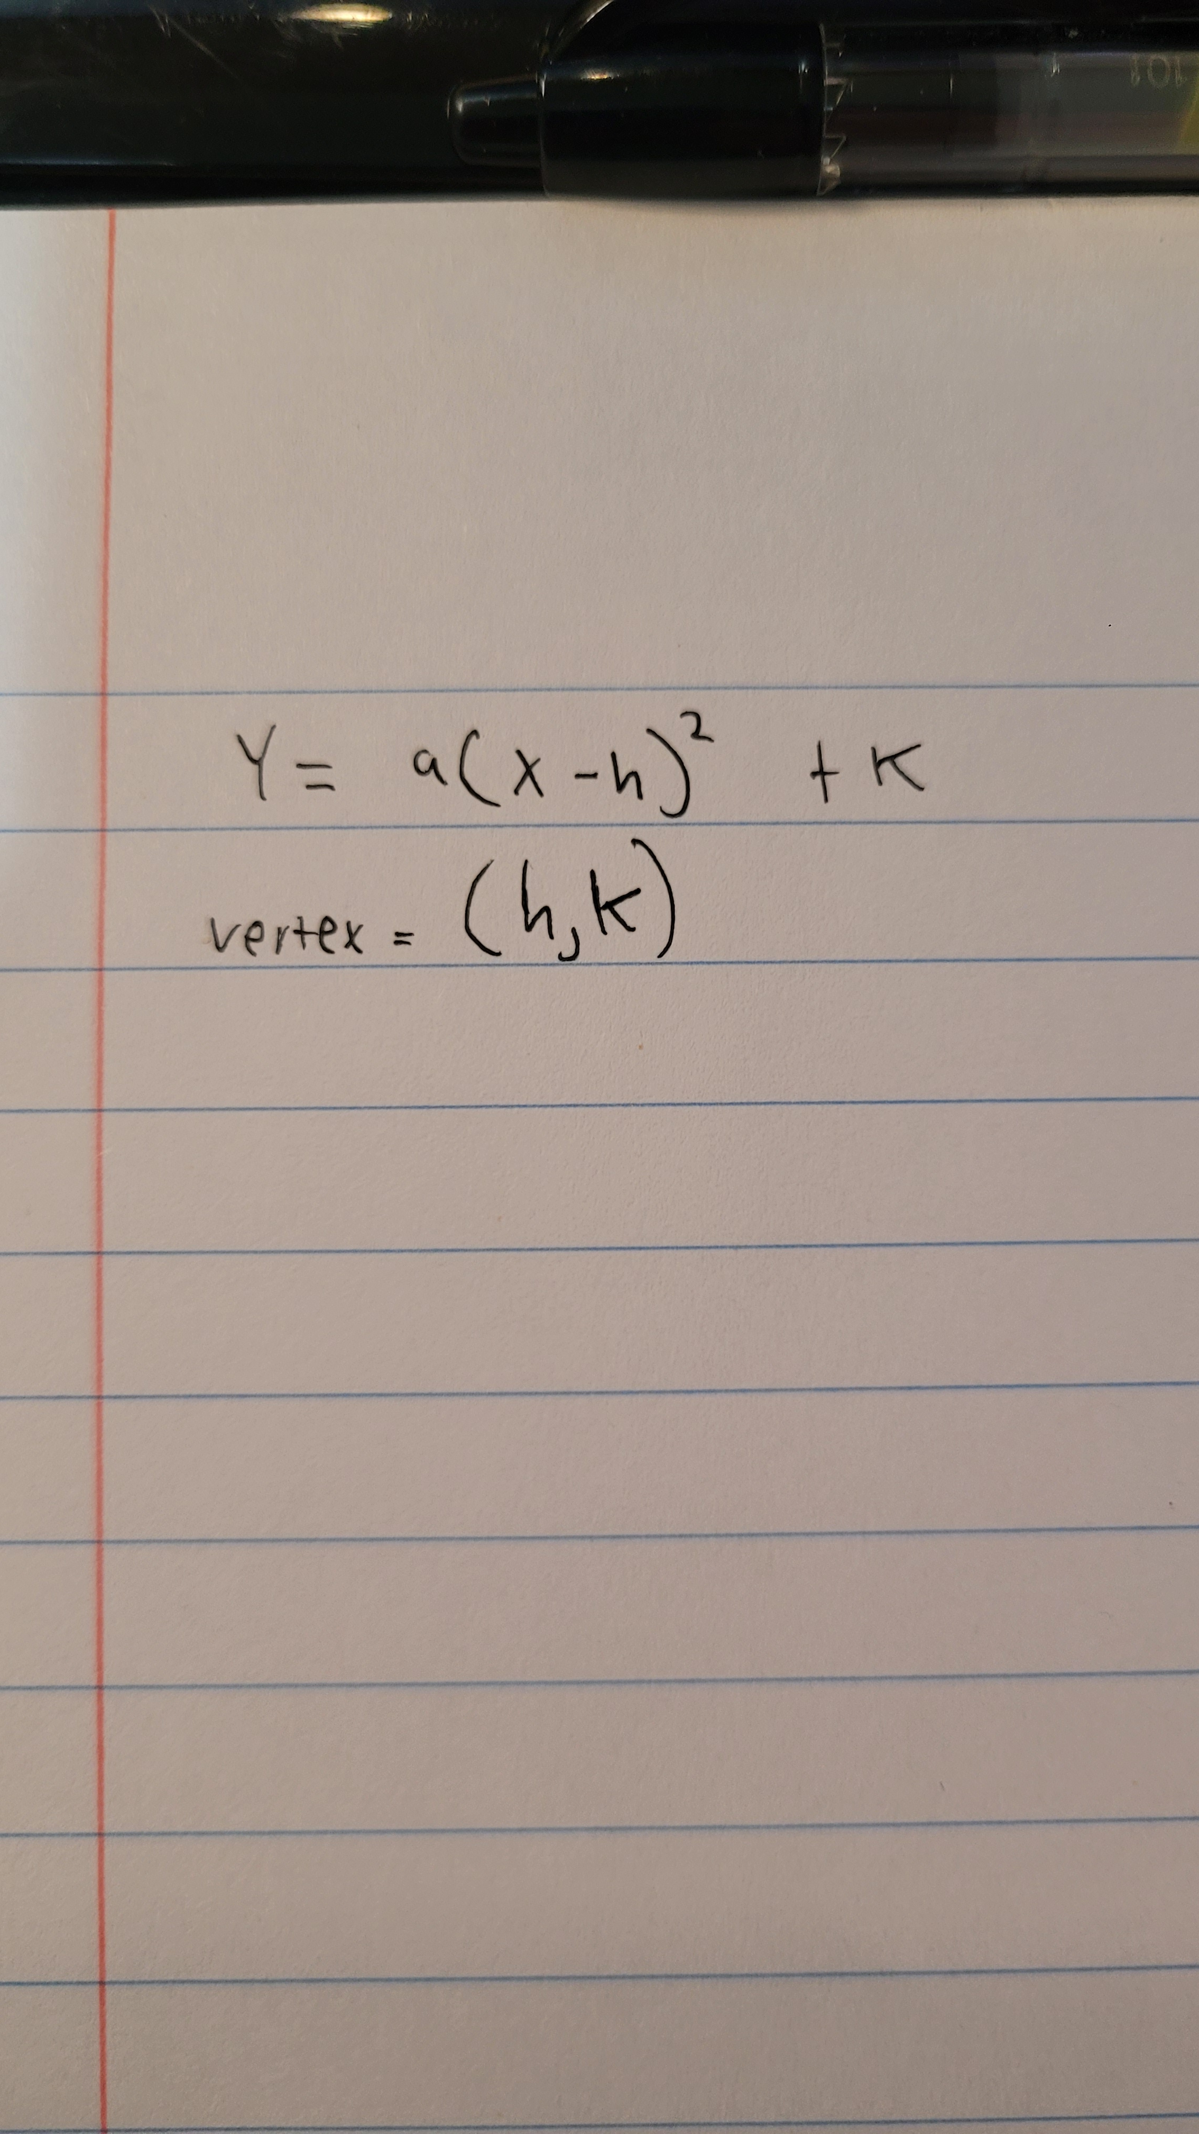

Vertex of a parabola → y = ax^2 + bx + c → h = -(b) / 2(a)

To find the vertex of a parabola using the standard form y=ax2+bx+c, use the formula x=2a−b​ to find the x-coordinate of the vertex. Then, plug that value of x back into the original equation to find the corresponding y-value. The vertex is the point  (2a−b​, y).

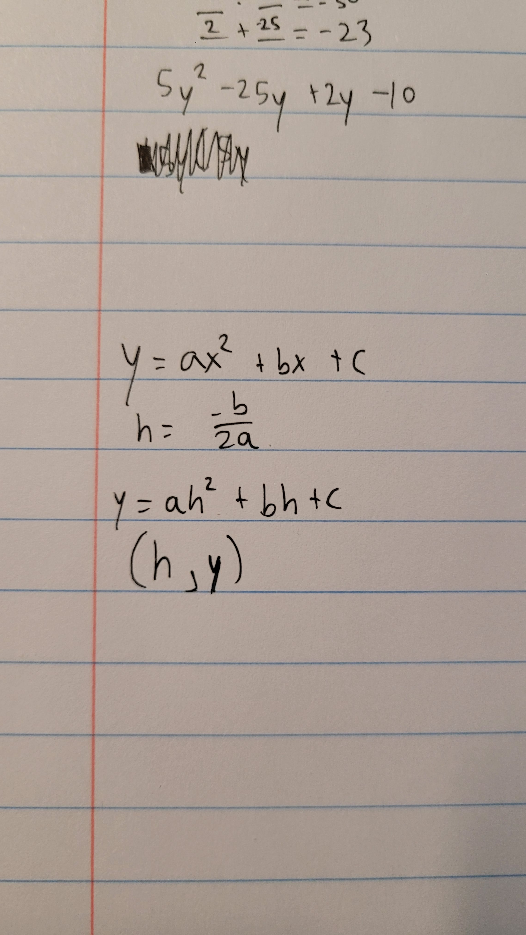

Factoring a Quadratic Equation:

To factor a quadratic equation of the form ax^2 + bx + c = 0, look for two numbers that multiply to (a)(c) and add up to (b). If a = 1, find two numbers that multiply to (c) and add to (b), then write the equation as (x + m)(x + n) = 0. If a≠1, use the numbers to split the middle term and factor by grouping. Always check your factors by expanding them to make sure they match the original equation.

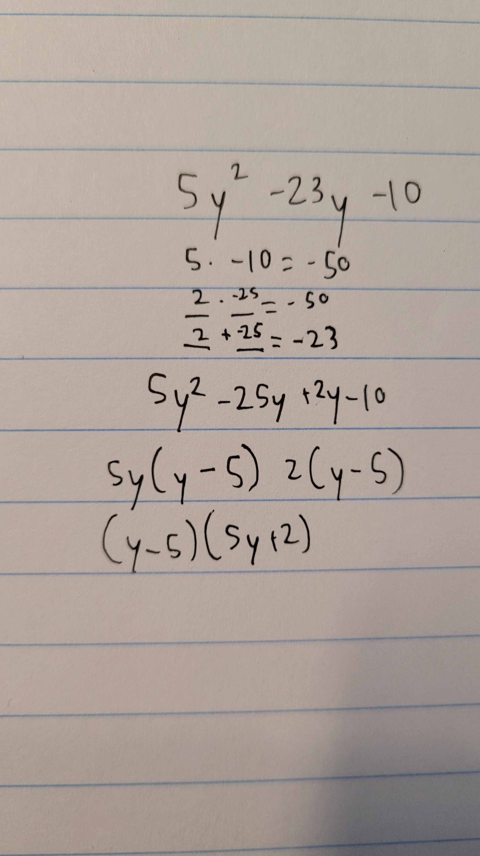

**Page 3: Geometry**

Circumference of a circle → 2(pi)(r)

To find the circumference of a circle, use the formula C=2πr, where r is the radius. This gives the distance all the way around the circle. You can also use C=πd if you know the diameter instead, since the diameter is twice the radius.

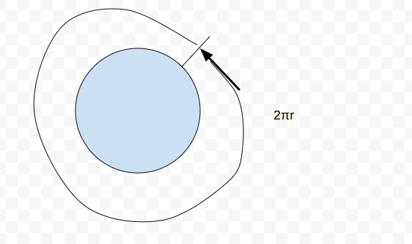

Area of a circle → (pi)(r)^2

To find the area of a circle, use the formula A=πr2, where r is the radius. This means you square the radius (multiply it by itself) and then multiply by π to get the space inside the circle.

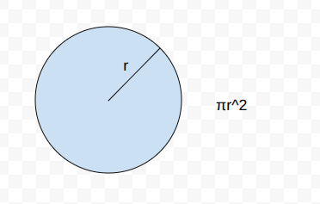

Surface area of a cylinder → (pi)(r)^2 + (pi)(r)^2 + 2(pi)(r)(h)

To find the surface area of a cylinder, use the formula A = 2πr2 + 2πrh, where r is the radius and h is the height. The term 2πr2 accounts for the area of the two circular bases, and 2πrh is the area of the curved side, which is a rectangle when unwrapped. Add both parts together to get the total surface area.

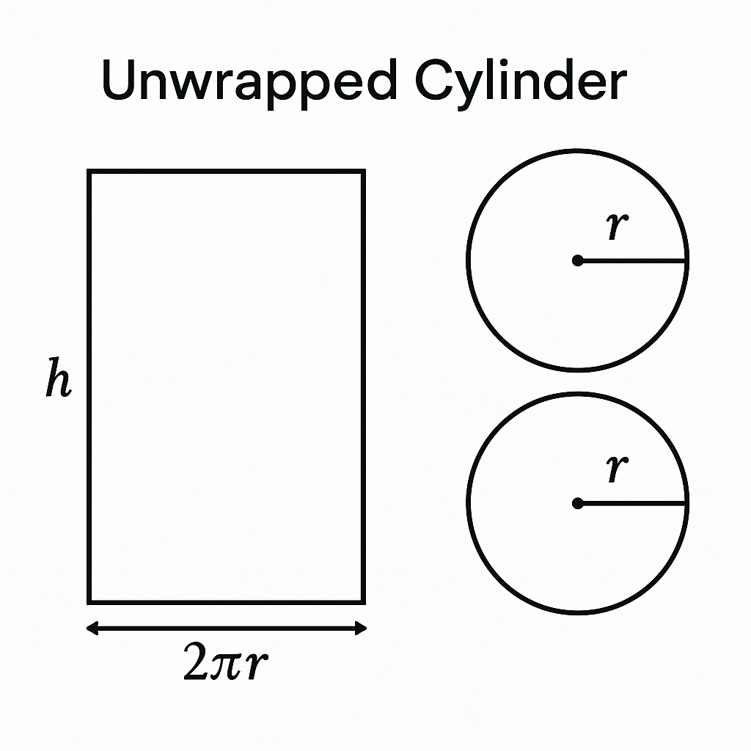

**Wireframes**

### Home child page

### I don’t care any more. Initially I made the joke on my logo image that I spent 5 hours on this wireframe but then it actually ended being 7, I don’t care how it looks, I don’t care that most of the images are hand made, no I will not keep relying on sketchy ai sites to generate images for my project, I don’t care anymore, I just want to go to bed, I have work tomorrow that actually matters, so heres my piece of garbage site plan. If the final product also looks like garbage, then my wildest expectations will have been exceeded, and I will give the team that made my site an A+ and a standing ovation. I don’t care. good night.